Report on Plant Naming Format for Weedy Area Availability
===========================================================================================================================
Objective:
The goal of this naming convention is to organize a list of 34 distinct medicinal or weedy plants based on their natural occurrence in weedy or uncultivated zones. This structured format is designed to be suitable for research, machine learning dataset labeling, and botanical analysis.

Naming Format Used:
rank_serial_plantname
Where:
rank = Availability rank in weedy areas (from 1 to 7)
serial = Overall order number (1 to 34)
plantname = Local/common plant name, written in lowercase with consistent spelling

Availability Rank Meaning:

Rank Meaning
1 Very High
2 High
3 Moderate High
4 Moderate
5 Moderate Rare
6 Rare
7 Very Rare

These rankings are based on real-world observation of plant availability in naturally weedy or unmanaged areas, particularly in Bangladesh and similar South Asian environments.

Examples:

1_1_thankuni — Most common plant in weedy areas, first in the list
4_18_joba — Moderate availability, 18th plant in the dataset
7_34_betal — Very rare in wild areas, last in the dataset

Model | Model Size | Accuracy (ACC) | Precision (PR) | Recall (RE) | F1-Score
0. VGG16 | 56.20 MB | 0.9748 | 0.9654 | 0.9615 | 0.9649
1. DenseNet121 | 26.98 MB | 0.9756 | 0.9694 | 0.9776 | 0.9726
2. EfficientNetB0_TL | 15.48 MB | 0.9587 | 0.9593 | 0.9587 | 0.9589
3. MobileNetV2 | 8.64 MB | 0.6573 | 0.6708 | 0.6573 | 0.6567
4. SqueezeNet | 889.09 KB | 0.9702 | 0.97 | 0.97 | 0.9701
5. MediNet-XG | 342KB | 0.9882 | 0.9875 | 0.9887 | 0.9879

Sl | Image | Annotation | Sl | Image | Annotation | Sl | Image | Annotation
1 | 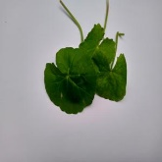 | 1_1_thankuni | 13 | 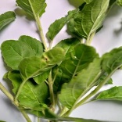 | 4_13_tulsi | 25 | 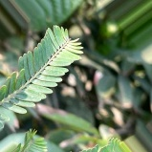 | 6_25_amloki
2 | 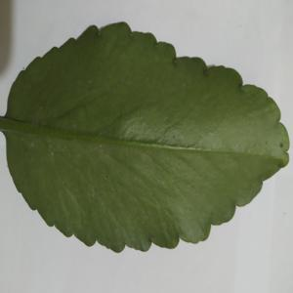 | 1_2_pathorkuchi | 14 | 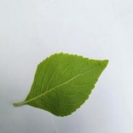 | 4_14_ramtulshi | 26 | 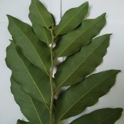 | 6_26_haritoki
3 | 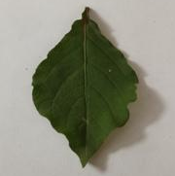 | 1_3_apang | 15 | 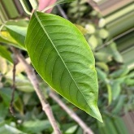 | 4_15_basok | 27 | 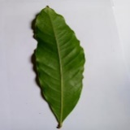 | 6_27_bohera
4 | 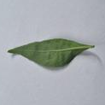 | 1_4_kalomegh | 16 | 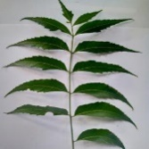 | 4_16_neem | 28 | 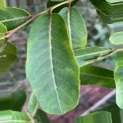 | 6_28_oshwagandha
5 | 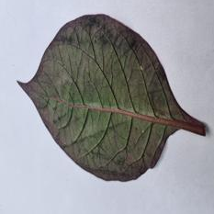 | 2_5_kaluchitra | 17 | 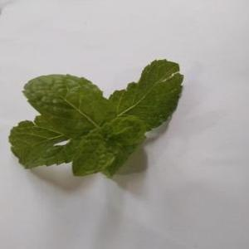 | 4_17_pudina | 29 | 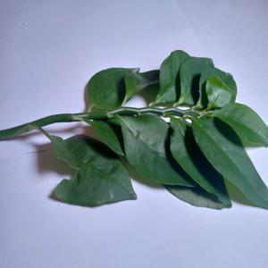 | 6_29_devils_backbone
6 | 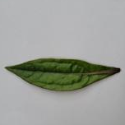 | 2_6_ayapan | 18 | 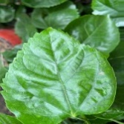 | 4_18_joba | 30 | 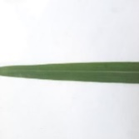 | 7_30_lemongrass
7 | 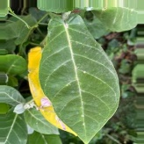 | 2_7_akondo | 19 | 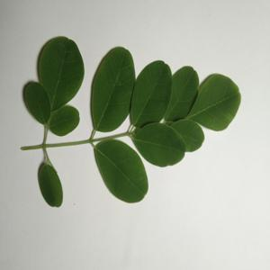 | 4_19_sojina | 31 | 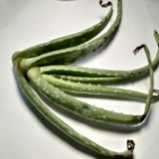 | 7_31_aloe_vera
8 | 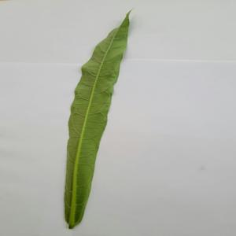 | 2_8_bamonhati | 20 | 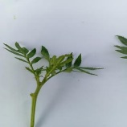 | 5_20_gandha | 32 | 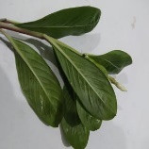 | 7_32_nayontara
9 | 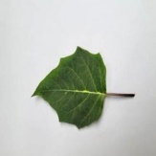 | 3_9_kalodhutra | 21 | 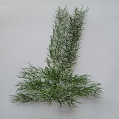 | 5_21_shotomuli | 33 | 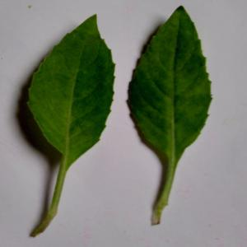 | 7_33_longevity_spinach (gainura)
10 | 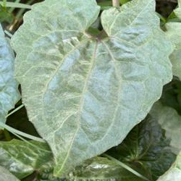 | 3_10_tarulata | 22 | 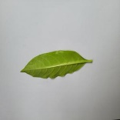 | 6_22_sarpagandha | 34 | 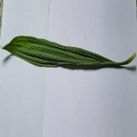 | 7_34_betal
11 | 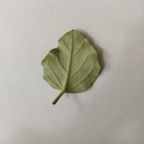 | 4_11_punarnava | 23 | 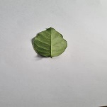 | 6_23_anantamul
12 | 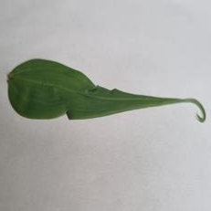 | 4_12_agnishikha | 24 | 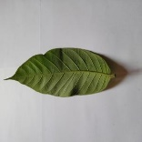 | 6_24_chapalish

I am continuing a research-paper project from a previous chat and want to keep the same technical writing style, structure, and terminology. The project is about a multimodal AI system (MediNet-XG) for identifying 34 weedy medicinal plant species in Bangladesh using about 17,050 RGB leaf images (~500 per class) and 1,020 plant-specific question–answer pairs stored in a JSON knowledge base. The dataset was collected with smartphones from multiple locations (e.g., Dinajpur, Saidpur, Parbatipur, Satkhira, Rangpur) plus public repositories (Mendeley), and all labels follow a rank-aware convention: rank_serial_plantname (rank 1–7 = availability in weedy areas, serial 1–34 = species index, plantname = standardized local name).
Below is the current draft text for the completed sections (Overview, Data Sources, Data Collection Techniques, Preprocessing, Annotation). Please keep the same tense, tone, and level of technical detail when helping me extend or revise the paper.
[PASTE your latest “Overview” section here]
[PASTE your latest “Data Sources” section here]
[PASTE your latest “Data Collection Techniques” section here]
[PASTE your latest “Preprocessing Steps” section here]
[PASTE your latest “Annotation Process” section here]
Now, continue with the next section of the methodology: [WRITE THE SECTION NAME YOU WANT NEXT, e.g., “Model Architectures and Training Setup”], following the same style and assuming the previous sections are already finalized.

$$f_θ: R^(H×W×3)→ ∆^(C-1)$$

